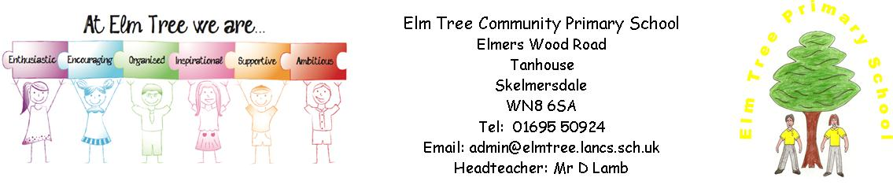

Elm Tree Community Primary School

SCHOOL CHARGING AND REMISSIONS POLICY
LANCASHIRE SCHOOL CHARGING AND REMISSIONS POLICY

Introduction

This charging and remissions policy complies with statutory requirements, has regard to the Authority's policy statements on charging and is reviewed on an annual basis.

Charging Policy

Activities without charge. There will be no charge for the following activities:
education provided wholly or mostly during school hours. This includes the supply of any materials, books, instruments, other equipment and also transport provided in school hours to carry pupils between the school and an activity;
education provided outside school hours if it is part of the National Curriculum, or part of a syllabus for a prescribed public examination which the pupil is being prepared for at the school, or part of religious education; instrumental and vocal music tuition which is part of the National Curriculum or a public examination syllabus being followed by the pupil or the first access to the Key
Stage 2 Programme of Instrumental and Vocal Tuition (Wider Opportunities);
instrumental and vocal tuition for children looked after; entry for a prescribed public examination including re-sits provided that a pupil has been prepared for it at the school.

Voluntary Contributions

The school may ask for voluntary contributions towards the cost of school-time activities to assist with funding subject to the following conditions:
• parents will be informed at the outset that there is no obligation to pay for a
particular activity;
• any children of parents who do not wish to contribute will not be treated any differently;
• where there are insufficient contributions to make the activity viable then the activity will be cancelled.

Chargeable Activities

The school may recover the full costs of the following activities which may be provided directly
or through commissioned services but charges will not exceed actual cost: educational or other activities provided wholly or mainly outside school hours which are not:

(a) part of the National Curriculum;

(b) part of a syllabus for a prescribed public examination which the pupil is being
prepared for at school;

(c) part of religious education.

Note: schools may wish to specify particular activities which are subject to charge eg school before and after school clubs. These could include any commissioned services.
• board and lodgings on residential visits (subject to remission arrangements);
• cost of entering a pupil for a public examination not prescribed in regulations and for the cost of preparing a pupil for that examination outside school hours;
• cost of entering a pupil for a prescribed public examination including re-sits where no preparation has been provided by the school;
• provision of instrumental and vocal tuition, which takes place during the school day and which has been requested by parents/carers;
• day care facilities.

Note: schools may wish to attach a schedule of current charges as an appendix to the policy.

Remissions Policy

• There will be no charge for board and lodgings for pupils whose parents are receiving the following:
- Income Support ( IS );
- Income Based Jobseekers Allowance ( IBJSA );
- Child Tax Credit (provided that Working Tax Credit is not also received and the family's income as assessed by Her Majesty's Revenue and Customs does not exceed a specified amount [£ 15,575 in financial year 2008/09]);
- the guarantee element of State Pension Credit;
- support under part VI of the Immigration and Asylum Act 1999;
- an income related employment and support allowance that was introduced on 27 October 2008.
• Charges for other 'chargeable activities' may also be fully or partly remitted. Details of any remission arrangements will be made clear when parents are informed of charges for individual activities.

Adopted by Governors Resources Committee 22.10.11
Approved by full Governing body 07.12.13

