Welcome to the Anglesey Outdoors Residential Information Pack
This pack contains all the information you’ll need to know about your child’s residential experience with us in North Wales. Our aim is to provide all our visitors with experiences that are safe, fun, exciting, educational, adventurous and unforgettable.

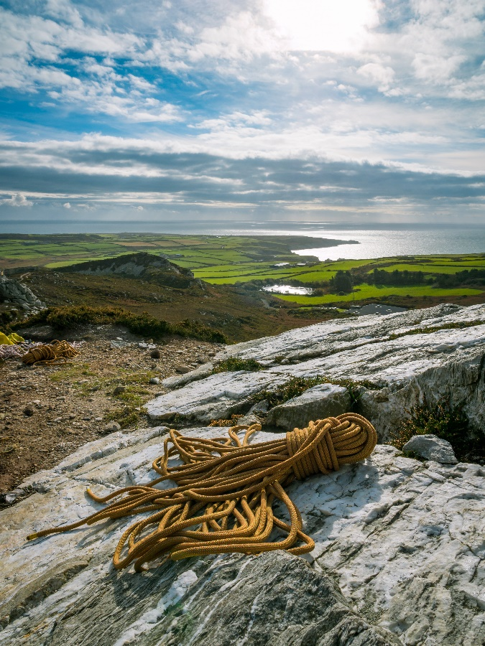
Contents Page
Why Anglesey Outdoors? | 3
Our Site | 4
Accommodation | 5
Safety in Accommodation | 6
Activities | 7
Safety in Activities | 8
Daily Schedule | 9
Our Food | 10
Sample Menu | 11
Further Info from Trip Organizer | 12
Medical Advice | 13
Kit Lists | 14
Photos | 17
Further Useful Information | 18
Contact Details | 19
Final Check List | 20
Why Anglesey Outdoors?
We’re pleased that your school or group has chosen Anglesey Outdoors as the provider for your child’s residential.
Our location and ethos make us a brilliant place for young people to come and enjoy the great outdoors under the guidance and care of our professional instructors. We will offer your child many fantastic opportunities to do things they would have never thought themselves able to, to shine in ways they didn’t know they could, to make new friends, and learn about the environment and the natural world around them.
Our students leave at the end of our courses with memories to last a lifetime, having learnt new things that they can apply to their day to day life, with better self-confidence, communication skills, risk awareness and management and most importantly they have a great deal of fun!
We pride ourselves in the personal development of your children.
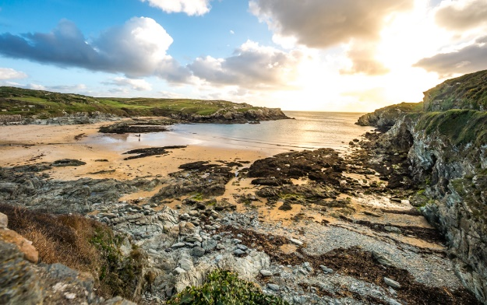
Our Site:
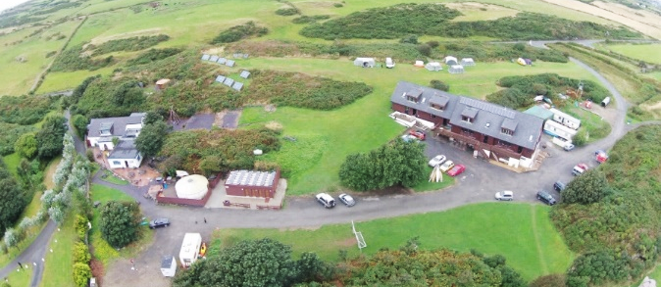
Anglesey Outdoors is situated by the rocky coast on Holy Island, which is the West most part of the Isle of Anglesey in North Wales. The site spans 14 acres of green space which is all inside the dedicated Area of Outstanding Natural Beauty of the Anglesey Coastline. On our site, we have loads of grassy space to enjoy playing ball games or relaxing, a pond full of wildlife, dozens of rabbits in the brush land, chickens roaming free and even some nesting owls and badger dens. We are only a 5-minute walk to a beautiful blue flag awarded sandy cove which groups enjoy visiting for sunsets and beach games.
We power what we can of the centre through our numerous solar panels and the biomass boiler on site as part of our green ethos.
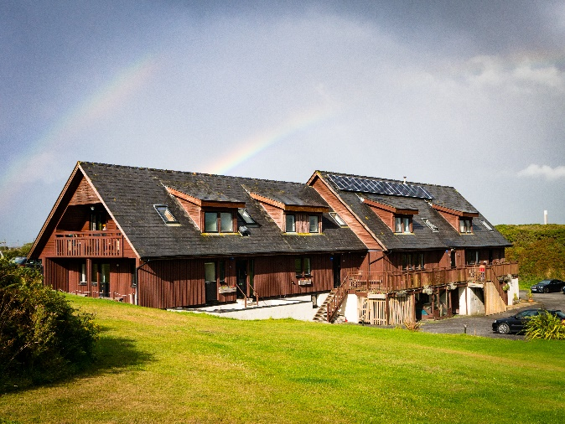
Our Accommodation:
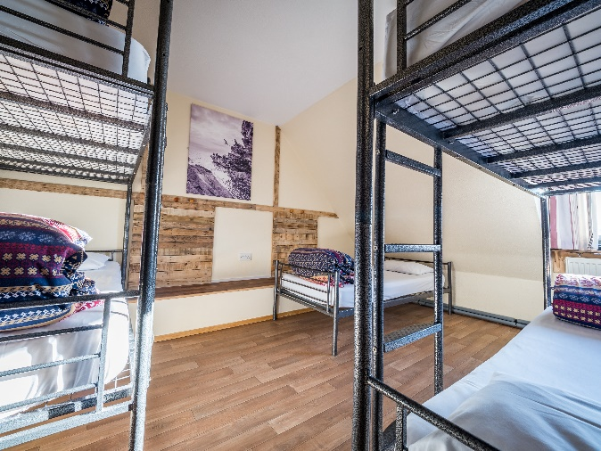
We have many different options for accommodation, most groups stay in the ‘Main Centre’ which is a large chalet style building and is the heart of our site. The Main Centre has a large dining room and lounge space, and several other communal rooms for groups to socialise in at the end of a busy day. It is always kept warm and comfortable by the biomass boiler, and is a nice space for groups to relax. The bedrooms range in size from twin rooms to 7 bed dorms, most of which have en-suite facilities. We have a very effective drying room to dry wet clothing from the day that’s powered by our biomass boiler. We provide all bedding, students will need to bring their own towels.
Safety in the Accommodation:
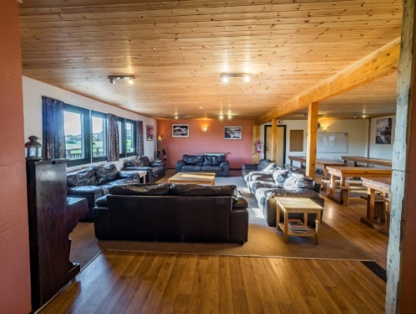
With your child’s safety being our primary concern, we do the following to ensure their safety whilst staying with us:
- The accommodation is secured with coded doors which only the group and staff will know.
- We have integrated fire alarm systems and preform a fire drill with groups.
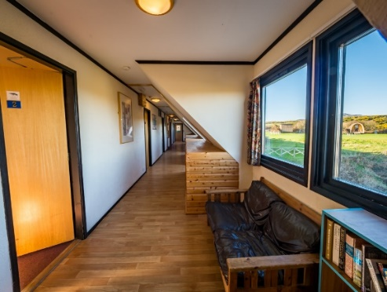
- We have a member of our staff nearby on call for any issues.
- School/group staff accommodation rooms are positioned strategically to ensure that the group will be well supervised at night and staff to hand for all young people.
- Our staff that interact with your groups are DBS checked.
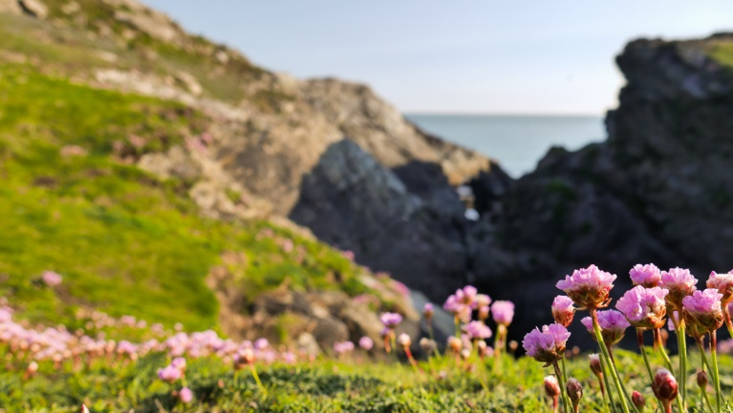
Our Activities:
We run a very diverse activity program at Anglesey Outdoors, and can cater for younger primary school groups through to teenage and adult groups. The program for the residential trip will be determined by the organiser of the trip. To really make the most of the activities, we try to utilise the best of the local environment, so that our students get to explore as many wild places as possible and discover new fascinating environments. We are fortunate to have some of the most impressive coastline and mountainous environments in the country.

Safety on Activities:
Anglesey Outdoors holds an AALA license (License Number R2348), which is a HSE governed license awarded to providers of outdoors activities to young people who can demonstrate that they follow good safety management practices; to allow young people to enjoy stimulating and exciting activities outdoors without being exposed to avoidable risk.
To achieve this license, we must ensure that:
- Our instructional staff are experienced, trained and qualified in the activities they deliver.
- Our equipment undergoes regular inspections and meets all required safety standards.
- All instructional staff are First Aid qualified and trained in incident management in remote locations.
- We have a stringent accident reporting system and review process.
- We have Risk Assessments and Guidance notes for all activities, the trip organiser is sent these if you want to view them.

A Typical Daily Schedule:
07:30 | Wake-Up
08:00 | Breakfast
09:15 | Activities
12:30 | Packed Lunch
13:15 | Activities
16:45 | Return to Centre, Free Time
18:00 | Evening Meal
19:30 | Evening Activity
21:00 | Hot Drink and Free Time
21:30 onwards | Bed Time
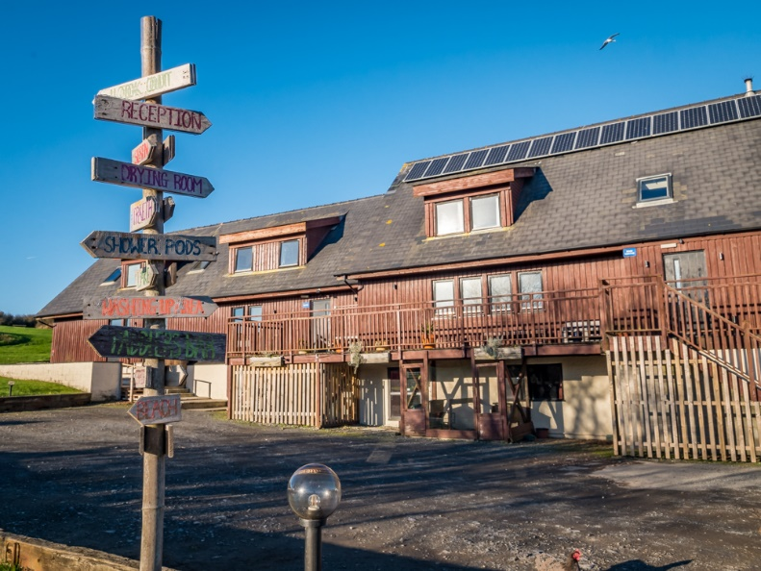
The schedule may be slightly different based on the request of the organiser, this is a standard schedule:

About our Food:
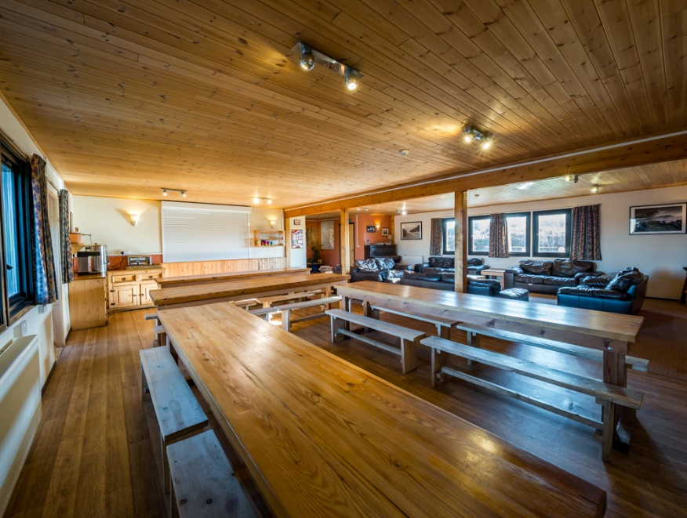
All meals at the centre are provided and we generally find that with all the fresh air and exercise our students have good appetites. For breakfast we offer cereals, toast and cooked breakfast options. Lunches are packed lunches with a choice of sandwich fillings. Dinner is a hearty main course followed by a desert. We aim to provide a healthy balanced diet with food prepared fresh by our kitchen staff. We cater for special dietary requirements and for food allergies. Please ensure that you make the trip organisers aware of any dietary needs in advance of the trip to allow us to plan the menu accordingly.
Sample Menu:
Below are some suggestions of meals that are offered at Anglesey Outdoors.
Breakfast | Lunch | Dinner
Choice of:  Cereal and Toast  Sausage Butty  Bacon Butty  Scrambled Egg on Toast  Beans on Toast  Full Breakfast  Inc: Tea Coffee Juice | Choice of 2 filled rolls:  Ham, Chicken, Cheese, Tuna, Egg  Piece of Fruit  Crisps  Chocolate Bar or Biscuit | Main Course:  Lasagna / Chicken Pie / Macaroni Cheese / Toad in the Hole  Dessert:  Ice Cream / Strawberry Gateau / Cholate Fudge/Apple Crumble

Further Information Provided by the Trip Organiser:
The following information should be provided to you by the organisers of the trip as these things are not determined by Anglesey Outdoors, contact the organisers for further details:
- Trip dates and duration
- Transport arrangements for getting to and from Anglesey Outdoors, including timings and pick up and drop off points.
- Which visiting staff will be attending, and contact information for these staff.
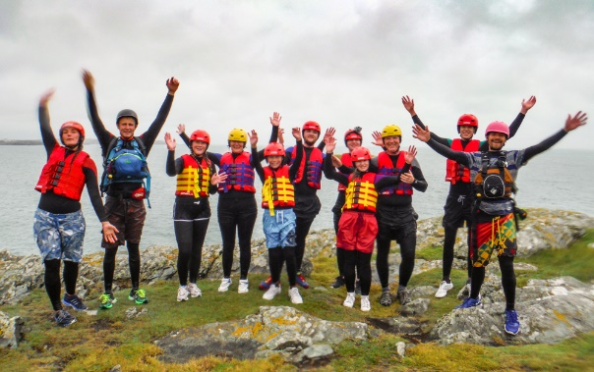
- The rooming plan for the students on the course.
- Pricing of the trip.
- Details on whether mobile phones and IT equipment is permitted on the trip.
- What spending money to bring (we have a small shop selling sweets and some souvenirs)

Medical Advice:
We at Anglesey Outdoors believe that these outdoor experiences that we offer should be an enjoyable experience available to anyone. We will do our best to accommodate young people with medical conditions and disabilities.
We are accustomed to working with young people with common medical conditions, such as asthma, diabetes, Reynaud’s syndrome, EpiPen carriers, and epilepsy. If you want to discuss any concerns further with us please feel free to call.
Please ensure that any medical details are recorded on the medical consent form that will be sent to you. If there are further details that we may need to know, please include this with the form. It is useful for us to know for any young person if they have any conditions, no matter how insignificant they may seem, including details of any recent injuries or past broken bones or dislocations etc.
Please ensure that any medication your child would normally need is taken on the trip, the trip organisers will arrange to collect these medications and administer them as required/prescribed during the trip. Items such as inhalers will be carried on all activities, by the instructors if required and will be checked to make sure it is present. If bringing an inhaler please ensure it has plenty of medication left in it or pack a spare as well.
Kit Lists:
Please read these kit lists thoroughly and ensure that all the necessary items are packed for your child. We recommend marking all items with your child’s name for ease of organising kit.
We have produced three kit lists:
- Essential Items – To be brought on a trip of any length
- Additional Daily Items – These are the daily essentials needed per day in addition to the above, pack a set per day of the trip.
- Activity Items – These items will be worn for activities, there is a good chance they will get wet and dirty as part of the fun.
It may be useful for you to print off these pages and use them as a check list whilst packing.
What not to bring: (please avoid bringing valuable items, any that are brought are done so at your own risk)
Hair Straighteners (because of the fire risk associated), unnecessary valuables, jewellery, expensive and/or delicate electrical goods.
Essential Items |  |  |  |  | Packed
Towel
Second Towel (for beach changing etc.)
Tooth-care (brush and paste)
Wash kit (soap/shower gel etc.)
Hair Brush & Drier etc. (if required)
Sun cream
Personal Medication
Water Bottle
Pajamas
Slippers (as easy wear indoor footwear)
Trainers (for travel and clean activities)
Underwear x2 sets (in addition to the underwear listed below)
Socks x2 pairs (in addition to the socks listed below)
Daily Items (Pack a set per day) | Day 1 | Day 2 | Day 3 | Day 4 |  | Day 5
T-shirt
Underwear
Socks
Trousers (don’t need a spare pair every day)
Jumpers (don’t need a spare every day)

Activity Items (will probably get dirty) | Packed
Fleece Tops x2
Thermal T-shirts x2
Synthetic Trousers/Jogging Bottoms x2
Thick Walking Socks x3
Swimwear
Baggy Shorts (to wear over wetsuits)
Plastic Bag/Bin Liner for wet clothing
Small Rucksack (needs to be able to go on back and fit a day’s food + drink + spare clothing)
Warm Hat
Warm Gloves
Sun Hat
Sun Glasses
Waterproof Jacket and Trousers
Wellies
Walking Boots
Trainers for Wet Activities (no pumps, AstroTurf, wetsuit boots, jelly shoes!)
Photos:
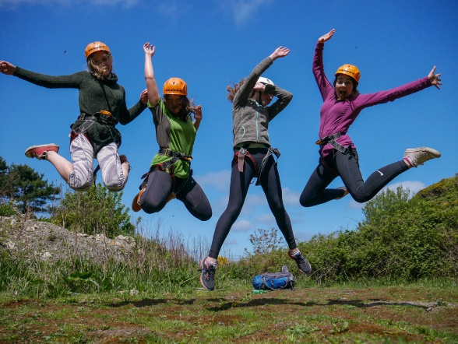
We will have tough cameras that go with us on activities to capture the moments, students are welcome to bring their own cameras at their own risk, but please realise there are many activities that it will not be suitable to bring them on.
The photos we take will be shared with you via our cloud hosting service. Please ensure you write your e-mail clearly on the medical forms to ensure you get the e-mail with instructions on using this. You’ll be able to download the photos for about a week once they are uploaded at the end of the course. Please ensure you get them in this period as we have limited space and will take them down after a week. If we get some particularly good photos, we may use them for promotional materials (booklets such as this), and share them on our social media platforms. We keep all details anonymous and avoid featuring faces. If you are not happy about this please mark on the consent form, and we will avoid photographing your child.
Useful Information:
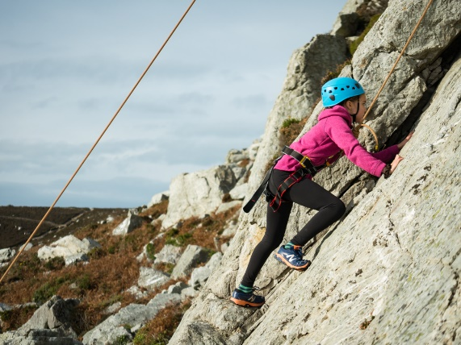
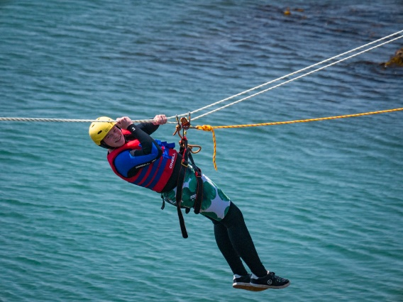
The trip organisers will let you know whether they permit students to bring mobile phones and IT equipment. It is worth noting that phone signal on our site is very poor, so if you struggle to call your child this is likely the reason in the evenings. On activity, it is usually unsuitable to take a phone to avoid damage to it. Any IT equipment is brought here and taken on activities at your own risk, so we generally recommend leaving them in the centre, or at home.
We do have WiFi at the centre, whether it will be made available depends on the trip organisers.

Contact Information:
Please only try to contact your children if there is an emergency whilst they are with us. We will have your contact information (that you write on the Medical Consent Form), and we will contact you should we need to. If you must contact us, please call the office number below during the day, and the office will try to contact the instructor on activity if needs be. In the evenings, it is best to try to contact the visiting staff as the office will be closed.
Our Contact Information:
Main Phone Line: 01407 769351
Secondary Number (emergencies only): 01407 763049
E-mail: info@angleseyoutdoors.com
Address: Anglesey Outdoors, Porthdafarch Road, Holyhead, Anglesey, LL65 2LP
Final Check List:
Please check this list a few days before your child comes on his/her residential with us to make sure that you have them adequately prepared for the trip:
Done?
Check the kit list and packed correct kit.
Read and Agreed to the ‘Participant Code of Conduct’ on the back of the Medical Consent Form.
Completed the Medical Consent form and given to organizing staff.
Given any medication to the trip organizing staff.
Made trip organizers aware of dietary requirements in advance of trip.
Made Anglesey Outdoors aware of any serious medical conditions.
Thank you for taking the time to read this booklet. We hope it has answered any questions you may have had. Should you have any further questions (not listed as information that the trip organisers will provide you with), please feel free to contact us.
We look forward to meeting your child and ensuring they have a fantastic time with us!

