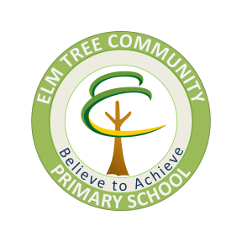
ELM TREE HOLISTIC OUTREACH SERVICE
(ETHOS)

Parent/Carer’s Views

Child’s Full Name: | Child’s School:
What problems is your child experiencing at school?

How has the school supported your child with these difficulties?

In what other ways do you think school could help you, your family and your child?

Do you know of anybody else/any other service that could help your child and your family?

Are you receiving support from parent partnership, social care, CAMHS, Best Start, Children’s Centre or any other service?

Date Parent/Carer’s views sought:

Name of Parent/Carer and relationship to the child:

