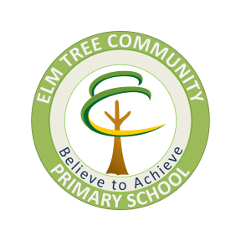
ELM TREE HOLISTIC OUTREACH SERVICE
(ETHOS)

Pupil’s Views

Child’s Full Name: | Child’s School:
What problems are you experiencing at school?

What do you think that school has done to help you?

How do you think that school could help you more?

Do you know of anybody else that could help you?

Date Pupil’s views sought:

Name and position of adult providing support when seeking the pupil’s views:

