ELM TREE
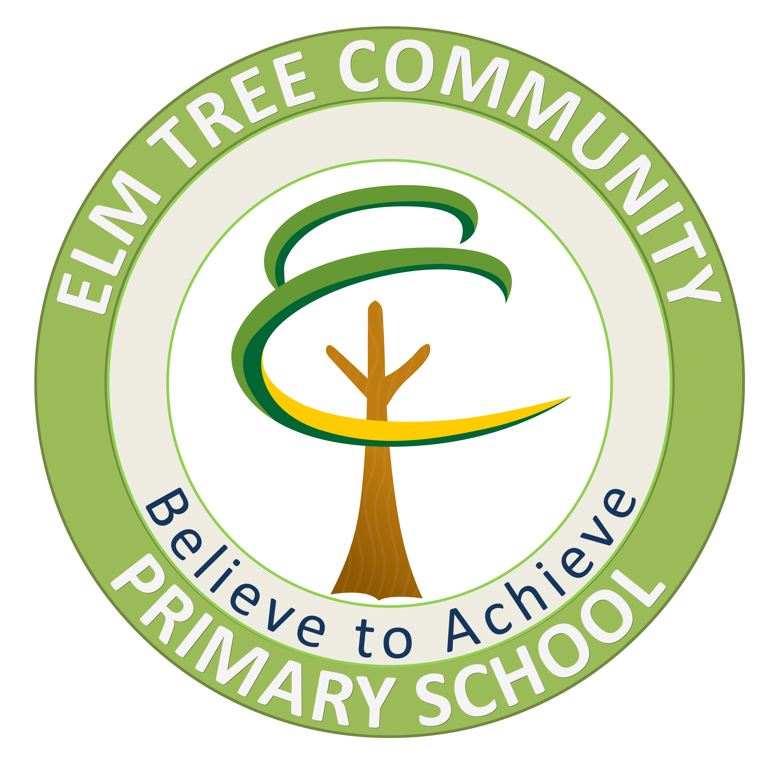

Holistic Outreach Service
Believe to Achieve

PUPIL REFERRAL REQUEST FOR
ELM TREE HOLISTIC OUTREACH SERVICE
(ETHOS)

To be returned to:
Dawn Hughes (Outreach Worker)
Elm Tree Community Primary School, Elmers Wood Road, Tanhouse, Skelmersdale, Lancashire, WN8 6SA
(01695) 50924
hughesd@elmtree.lancs.sch.uk

Revised - September 2019

Please attach the following with the referral form:

TICK
Common Assessment Form (CAF) and TAC Meeting Minutes

Chronology of Action

Class Teacher/SENCO/Headteacher summary (Performa and Appendix 1included)

Attendance (print out from SIMS)

Assessments

Evaluated IEPs/IBPs

‘All About Me’ Profile (if available)

Fixed Term/Permanent Exclusion information

Child’s View

Parents/Carers View

Boxall Profile Assessment (OPTIONAL)

Behaviour Logs/ABC’s plus Evaluations

Reports from other services and agencies involved:
IDSS

CAMHS / Medical Reports

Children's Social Care

Voluntary Agencies

Other

Section 1: The Child
Child’s First Name: |  | Family Name:
DOB: |  | UPN: | Date on role:
Year Group: |  | Male | Female

Family Details
Parent/Carer |  | Parent/Carer
Name: |  | Name:
Relationship: |  | Relationship:
Address: |  | Address:
Postcode: |  | Postcode:
Telephone No: |  | Telephone No:

Child’s Health Details
Any medical conditions? (ADHD, ASD, DYSPRAXIA, EPILEPSY)

Is the child taking any medication? (if yes please give details)

Is the child or has the child been known to Social Care? Yes No

If yes, please give details:

Is the pupil eligible for Pupil Premium? Yes No

If ‘Yes’ briefly state how this money has been spent:

Current level of support  (and dates) | Learning | Behaviour
Formal Assessment
EHCP Statement (State category)

Is the pupil attending full time? Yes / No
Recent Exclusions: Yes / No
If Yes date(s) of Exclusions:

Section 2: The School
School Name:

School Address:

LCC School Number:

Telephone Number:

Headteacher:
Name:

Email:

SENCo:
Name:

Email:

Class Teacher:
Name

Email:

TA: (if applicable)
Name:

Email:

IDSS SENDO:
Name:

Link EP:
Name:

DSP Staff Member:
Name:
LA Adviser:
Name:
Previous school(s) the pupil has attended:

Mainstream School’s Summary Of Need To Support Referral To ETHOS
(Please refer to Appendix A)

Summary Of The Pupil’s Difficulties:
Emotional:

Social:

Behavioural:

Medical:

Learning:

Other:

Section 3: Standardised Assessments

If the child is Early Years, please attach EYFS Profile

National Curriculum Levels |  | SATS | Date | Current Teacher Assessment | Date
 | Reading
 | Writing
 | Numeracy

Other Tests:

Name of Test | Scores | Comment

I confirm that I agree to the terms of the referral process and agree that relevant data can be shared with professionals working at Elm Tree Community Primary School and, in addition:
- Professionals at IDSS (Educational Psychologists, SENDOs and SEN Officers).
- CAMHS (if they are working with the child).
- Any other professionals involved in supporting the child.

Print name of person completing this form:
Position in school:
Parent/carer signature: | Date:
Head Teacher’s signature: | Date:

It is essential that this form is accurate and complete. Incomplete forms may be returned.

Appendix A

Emotional –
- Emotional well-being: secure, stable, anxious, intolerant? (usually emanating from home, but could be disaffection with school if child has felt unsuccessful in the classroom)
- Emotional intelligence? Does this child know what he/she is feeling, why, or how to control it?
- Attachment: Is this child able to form positive attachments with adults both at home and at school.
- Self-esteem: as a learner, as a friend, as a child liked by adults and pupils?
- Self-image: poor, dysfunctional, unrealistic, egocentric, arrogant (all of these may however be symptoms of low self-esteem)?
- Empathy: consideration for others, sympathetic, remorseful?
- Conscience: has this child developed a conscience, follows rules, wants to please, understands right from wrong?
- Trust: Does this child trust adults to advise and support him/her? Or does this child need to have control?
Social –
- Has this child developed appropriate social skills? Does he/she need to be directly taught these skills?
- Can he/she develop reciprocal relationships with peers?
- Can he/she develop trusting relationships with adults?
- Can he/she trust adults enough to relax and enjoy social interactions?
Behavioural –
- Does this child comply with teacher requests?
- Does this child demand adult attention in negative ways?
- Does this child demand peer group attention through disruptive behaviour?
- Does this child lose control?
- Does this child become angry, upset or frustrated?
Environmental –
- Some children may be hungry, tired, poorly clothed, withdrawn or exhibit a sudden behaviour change.

